CS 499 Milestone Four: Enhancement Three – Databases
Justin Hartwick

Artifact Description
The artifact selected for this enhancement is an Animal Shelter Dashboard originally created for CS 340: Client/Server Development. The original version demonstrated basic CRUD operations using MongoDB and displayed animal shelter data through a Python-based dashboard. For CS 499, this artifact was enhanced to better demonstrate database design principles, secure data access, and efficient data retrieval practices.
The enhanced artifact consists of two primary components:
- A MongoDB CRUD module (CRUD_Python_Module.py) that encapsulates all database operations.
- A Dash-based interactive dashboard (ModuleSixMilestone-Hartwick.ipynb) that retrieves, displays, and visualizes data from the database.
This enhancement was completed during CS 499 Milestone Four to align the artifact with the database-focused outcomes of the Computer Science program.

Justification for Inclusion in the ePortfolio
This artifact was selected for inclusion in my ePortfolio because it clearly demonstrates my ability to design, implement, and enhance database-driven applications. The project showcases practical database skills that are directly applicable to real-world software development, including secure database connections, structured data access, and performance-aware querying.
Several specific components highlight my database expertise:
- Centralized CRUD Abstraction:
All database operations are handled through a dedicated AnimalShelter class. This separation of concerns improves maintainability, security, and scalability by isolating database logic from the application interface.
- Secure MongoDB Authentication:
The enhanced version establishes an authenticated MongoDB connection and validates connectivity at startup. This demonstrates awareness of database security practices rather than relying on unsecured or anonymous access.
- Efficient Data Retrieval (Enhancement):
To improve performance and scalability, the dashboard now uses field projection and result limiting when querying the database. Only relevant fields are retrieved, and the number of records loaded is controlled, reducing memory usage and query overhead.
- Interactive Data Visualization:
Database records are displayed in a sortable and filterable data table, and geographic coordinates stored in the database are visualized on an interactive map. User selections dynamically update the map, demonstrating effective integration between stored data and application behavior.
These enhancements significantly improve the original artifact by emphasizing efficient data access, secure design, and real-time interaction, making it well-suited for demonstrating database competency.

Planned Outcomes and Progress
In Module One, I planned to use this artifact to demonstrate progress toward the Computer Science program outcome related to software engineering and database development. This enhancement successfully meets that goal.
Through this milestone, I demonstrated:
- The ability to programmatically store, retrieve, and manipulate database records
- The application of database design techniques that improve performance and maintainability
- The integration of database systems into a functional, user-facing application
At this time, no updates are needed to my outcome-coverage plan, as the enhancement aligns well with my original intentions.

Reflection on the Enhancement Process
Enhancing this artifact provided valuable experience in refining database-driven systems beyond basic functionality. One of the most significant learning outcomes was recognizing how design decisions at the database level directly affect application performance and usability. Implementing projections and limits reinforced the importance of retrieving only the data an application actually needs.
A major challenge during the enhancement process involved diagnosing and resolving database authentication and connection issues. Working through these problems strengthened my understanding of MongoDB security configuration and reinforced the importance of validating database connectivity early in the application lifecycle.
Additionally, integrating database queries with interactive visual components highlighted the need for careful data validation and error handling, especially when working with user-selected records and geographic data.
Overall, this enhancement deepened my understanding of database-backed application design and reinforced best practices for building secure, efficient, and maintainable systems.

Screenshot Evidence
Figure 1. Enhanced Animal Shelter Dashboard with MongoDB Integration
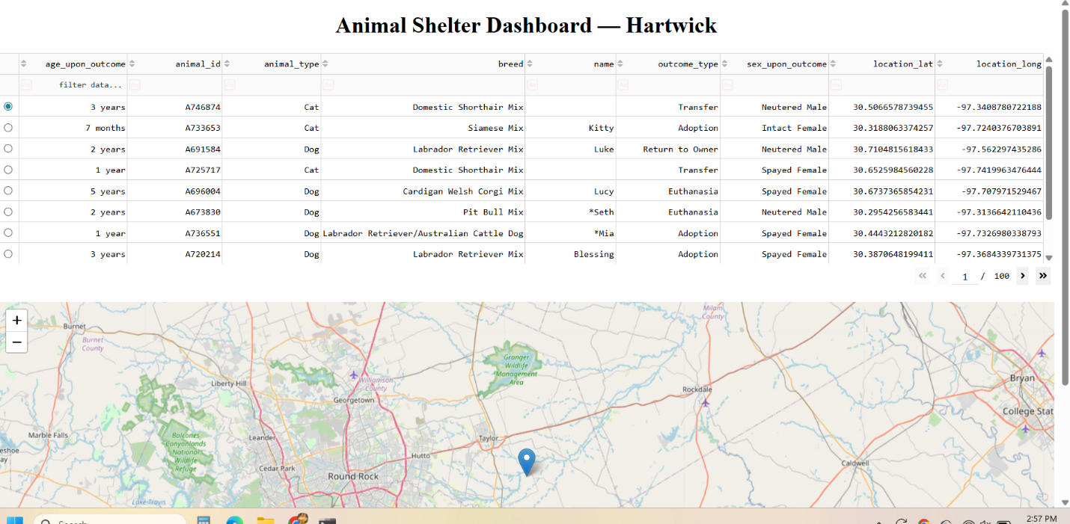

Conclusion
This database enhancement demonstrates meaningful progress toward professional competency in database design and implementation. By improving data access efficiency, strengthening security practices, and integrating database functionality into an interactive dashboard, this artifact represents a polished and practical example of my database skills and serves as a strong addition to my ePortfolio.

